Opportunistic Assessment of Bone Density in the Cervical Spine Using Dental Cone Beam Computed Tomography
Reva Bhatt

- Introduction

Osteoporosis is a disease that weakens bones and makes them susceptible to fractures. To evaluate the bone health and further risk of osteoporosis, it is necessary to timely assess the changes in the bone density. Screening for osteoporosis uses a dual energy X-ray absorptiometry, which utilizes radiation to help measure the bone mineral content, helping to determine the bone strength; this is the most common way to diagnose osteoporosis.
Surgeons' most common visualization tool to identify the next steps are computerized tomography (CT) scans during preoperative planning. These steps are determined by approximating bone measurements, positional information, and analyzing potential complications that could occur within surgery through these CT scans. They also provide additional information, such as data when other imaging modalities fail at providing accurate or complete data.
Cone Beam Computed Tomography (CBCT) is a new development within technology that differs from traditional dental radiographs since it provides three-dimensional information. CBCT is applied mostly in dental practices, visualizing teeth and jaws for pathology, surgical planning for jaw and TMJ joint reconstruction, structural maxillofacial deformity, preoperative dental implant site assessment, and appropriate treatment planning. Further, CBCT is used within the evaluation of cervical skeletal maturation, growth assessment, diagnosis of obstructive sleep apnea, and temporomandibular disorders. Prior studies have thoroughly looked at the use of two-dimensional dental radiographs, such as panoramic and intraoral periapical radiographs, to detect osteoporosis—specifically through the analyses of trabecular patterns of jawbones. Measurements of trabecular patterns and texture using dental radiographs were capable of predicting osteoporotic risk. These findings provide support for the utility of dental radiographs in bone health assessment. However, these two-dimensional dental radiographs are known for their compromise on image measurements due to factors such as geometric distortion.
In comparison to traditional CT scans, CBCT initiates multiple advantages, including high spatial resolution (preferred for bone architecture evaluation), high image accuracy, low cost, faster scan time, ease of use, compact machinery, and low radiation exposure. The possibility that CBCT can serve as an effective alternative to traditional CT or DXA scans is highly relevant and valuable for medical and dental professionals. One of the target populations of patients who can benefit from bone density assessments using CBCT scans are those who do not have DXA scans. Since DXA scans are not a standard of care for many patients, it is common for patients to not have DXA scans available for early osteoporosis risk assessment. However, CBCT scans are common in dental practices, and can serve as an opportunistic assessment of bone density. These scans are more convenient, easily accessible, inexpensive, and a large portion of the population may have these scans available from dental visits. It is additionally important to note the limitations of CBCT, including drawbacks on image clarity due to interference of artifacts and noise.
Image analysis of CBCT scans provide radiographic density of specific regions within the scan. When performing radiographic image analysis on CBCT scans, it is necessary to calibrate radiographic density values based on air and spinal canal regions of the scan. The final calibrated radiographic density of a bone region is referred to as a Hounsfield Unit (HU).
Current literature presents a need for further studies to support the reliability of CBCT analysis in assessing bone density. This study differs from previous research comparing bone mineral density analysis through DXA and CBCT in several ways. This study examines a large sample population and evaluates both male and female subjects within a broad age range. The purpose of this study is to provide support for the correlation between CBCT radiographic density and bone density. We hypothesize that lower HU values represent decreased bone density. This will be supported if a direct relationship exists between CBCT radiographic density (HU value) and DXA report measures such as bone mineral density (BMD), T-score, and Z-score within the lumbar spine, femoral neck, and femur. The existence of this relationship could provide support for the accuracy of CBCT radiographic analysis in predicting risk of osteoporosis. Additionally, this study will examine whether radiographic density trends seen in female CBCT scans support known age-related bone loss trends in postmenopausal women.
Few studies have investigated the potential use of CBCT images for opportunistic assessment of bone health as an alternative to traditional CT and DXA. Specifically, this study examines changes in bone density of the C3 vertebrae. Since the use of CBCT beyond dentistry is not well-established, the overarching goal of this study is to provide support for the reliability of dental CBCT images in the determination of bone health for orthopedic applications.

- Methodology

Study Selection and Acquisition
This is a retrospective study involving radiographic image analysis and chart review to analyze DXA imaging reports. CBCT scans were obtained between 2018-2020 from the Hospital of the University of Pennsylvania clinical database. The images were obtained using the i-CAT™ CBCT Machine (Imaging Sciences International, Pennsylvania) at 120 kVp, 5 mA with FOV – 17 x 13 cm. Patient health information on all scans were de-identified and scans were reassigned a study identifier number.

Radiographic Analysis of CBCT Scan to Calculate HU
Fiji (ImageJ 2.0 application (1.46r National Institute of Health, USA – Java 1.6.0_20 [32 bit])) software was utilized to analyze 1022 CBCT images that display the skull, jaw, facial bones, and upper portion of the cervical spine. Select patient scans were imaged such that the C3 vertebra appears partially or completely omitted. These images with obscured or missing C3 vertebra were excluded from the sample data. The density measurements of three regions of interests (ROIs), including the C3 vertebra, spinal canal adjacent to the C3, and pharyngeal airway, were taken for internal calibration of CT Hounsfield Units (HU) to calculate C3 bone density (Figure 1). To obtain accurate and consistent density measurements of the ROIs, ImageJ was used to orient each CBCT scan to display the midsagittal view of C3 vertebrae. The polygon selection tool was used to isolate the C3 vertebra cancellous bone and radiographic density of that region was measured.

Analysis of DXA Scan Reports
Of 1022 male and female patients, we identified 186 patients with an additional DXA scan completed within +/- 11.83 years of the CBCT[1] examination. DXA reports were reviewed to obtain bone mineral density (BMD), T-scores, and Z-scores within the lumbar spine, femur, and femoral neck. JMP statistical software was used to compare the relationship between HU value within the C3 vertebra and the BMD, T-score, and Z-scores extracted from DXA reports.
Patient Demographics
Patient demographic variables including sex, age, BMI, race, and ethnicity were collected through our institution’s electronic medical records, as shown in Table 1.

Bone Density Trends in Female CBCT Scans
CBCT scans of 919 female patients[2] [WX3] with ages ranging from 10-88 years were obtained, with 339 patients over 50 years of age. We analyzed whether an age-related loss of bone density in females was evident based on radiographic analysis of the C3 vertebra. We stratified this patient cohort by age group (<50, 50-88 years of age) to assess changes in C3 radiographic density in females with age.

Statistical Analysis for Female CBCT Scans
The linear and spline lines of fit, confidence intervals, linear equations, statistical significance, and R values were calculated using JMP statistical software based on measurements retrieved from 919 female patient scans.

- Results

HU in the C3 Vertebrae and DXA Report Measures
Of the 198 patients with DXA scans, 166 patients had DXA reports that included femoral neck T-score, 169 patients with femoral neck BMD, and 156 with total hip T-score. There was a significant direct relationship between HU value of the C3 vertebrae and femoral neck T-score (r=0.513, p<0.001) (Figure 2), femoral neck BMD (r=0.505, p<0.0001) (Figure 3), and total hip T-score (r=0.534, p<0.001) (Figure 4).
These results indicate that CBCT radiographic density analysis can provide similar information as certain DXA measures. In a DXA report, the T-score describes how an individual's bone density compares to others of the same age and sex. Specifically: (a) T-score ≥ -1 indicates healthy bone density; (b) -2.5 < T-score < -1 indicates osteopenia; (c) T-score ≤ to -2.5 indicates osteoporosis. Based on our analysis, an individual with osteoporosis (T-score ≤ -2.5) correlates with a low HU value (153-416 HU). This relationship is logical in that individuals diagnosed with osteoporosis have lower bone density, which is reflected by lower radiographic density.

HU Value Trends Support Expected Age-Related Bone Loss in Females
A decline in bone density with age was observed (-2.60 HU/year, p<0.0001). A rapid decline was observed after 50 years of age (-3.33 HU/year, p<0.0001). These findings are consistent with previously established trends depicting changes in BMD as a function of age in females, such that peak loss of bone density occurs during the first few years post-menopause, beginning around ages 50 to 54.

- Discussion

This study examined the C3 vertebrae due to its consistent visibility on head CBCT scans. Radiographic density measurements vary based on fluctuating variables including object position, X-ray energy, photon flux, and spatial resolution. Therefore, it was necessary to perform internal calibration to yield HU values. This study utilized areas with known density values, such as the pharyngeal airway and spinal canal, to calibrate the radiographic density within the C3 vertebrae.

Validity of HU Values Based on DXA Reports
The significant direct relationships found between HU value of the C3 vertebrae and various DXA report parameters (femoral neck BMD and T-score, total hip T-score) suggests support for CBCT radiographic analysis in bone assessment. Based on study results, a lower HU value correlates with an increasingly negative T-score and lower BMD, which correlates with lower bone density. Therefore, the trend we found between HU value and DXA measures is reasonable in that individuals with lower bone density are at greater risk of osteoporosis. This finding provides support for the validity of the HU value calculations through CBCT radiographic density analysis for bone health assessment.

Age-Related Bone Loss Trends in Females
Females experience age-related bone loss, with a particularly high rate of decline occurring the first few years post-menopause. Bone loss correlates with a decline in bone composition, structure, and function, which increases the risk of osteoporosis in postmenopausal females. Estrogen plays key roles in these processes by increasing calcitonin and decreasing bone resorption and reducing calcium lost by the kidney. When females reach menopause, their estrogen decreases, thus altering the proper cycle of bone maintenance. Due to estrogen’s influence on bone health and BMD, males have significantly lower rates of osteoporosis than females. Studies have found a noticeable decline in BMD in females during postmenopausal years with annual rate loss around 1.8%-2.3% in the spine and 1.0%-1.4% in the hip.
The finding that female subjects aged 50-93 years exhibited a significant decrease in bone density, as reflected by CBCT radiographic density, is in line with scientific literatures exploring the increased prevalence of osteoporosis in postmenopausal women. The ability to identify these established trends using CBCT scans provides evidence for the utility of obtaining bone density measurements through CBCT image analysis. Our findings may be useful in providing evidence in support of CBCT scans as an alternative method of osteoporosis screening and assessment of bone quality in orthopedic and dental surgery patients.
Patients who are unable to obtain DXA screenings may find it useful to assess their osteoporosis risk based on dental CBCT scans. The increasingly common use of dental CBCT imaging systems by dental professionals yields a possible alternative for these patients. This is particularly relevant for male patients. In an analysis of 8,262 patients eligible for osteoporosis screening, only 18.4% of male patients performed DXA scans for osteoporosis screening, as opposed to 60% of women.

Study Limitations
Of the patients who had previously completed DXA scans, several patients did not have DXA reports that included all nine parameters (BMD, T-score, and Z-score of lumbar spine, femoral neck, and femur). Therefore, we were unable to maximize the sample size when analyzing linear relationships between HU values in the C3 vertebra and these various DXA report parameters. Additionally, our study cohort did not exclude patients with bone metabolic disorders and was representative of the general population.
A notable limitation we encountered when analyzing CBCT images was the occasional lack of image clarity due to artifact interference. Artifacts appear as distortions and noise on the scan, and result from variables that are not related to the subject undergoing the scan. The presence of artifacts can be caused by a variety of sources, including beam hardening, patient movement, and scanner-related interferences. Select patient scans were imaged such that the C3 vertebra appeared to be partially or completely omitted. Images with obscured or missing C3 vertebra were excluded from the sample data.

- Conclusion

This study has yielded support for the use of CBCT analysis in predicting low bone density and osteoporosis risk. The findings on predicted bone loss trends in females with age, as well as the direct relationships between HU value and DXA report parameters serve as evidence. CBCT radiographs serve as valuable and precise resources that can be beneficial for both patients and providers. Patients can derive significant advantages when dental and orthopedic providers collaborate by utilizing routine dental radiographs. The potential use of CBCT technology continues to grow with its increased commercialization and access by practitioners.

Future directions of the study:
Considering the limitations noted, the continued goal of this study is to expand the cohort of patients with DXA scans. Although the initial CBCT cohort included 1022 patients, only 198 had existing DXA reports. This reflects the study purpose to provide an alternative to assessing bone health if DXA scans are not available. Additionally, it may be useful to review each patient to exclude those with existing bone metabolic disorders or other conditions that may adversely affect bone health. This would establish greater homogeneity within our patient cohort.

Figure 1: Regions of interest marked by blue enclosed areas. Radiographic density values were measured for (a) pharyngeal airway, (b) C3 vertebrae, and (c) adjacent spinal canal
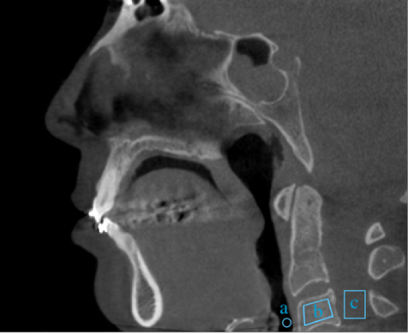
Figure 2: HU Value vs. Femoral Neck T-Score
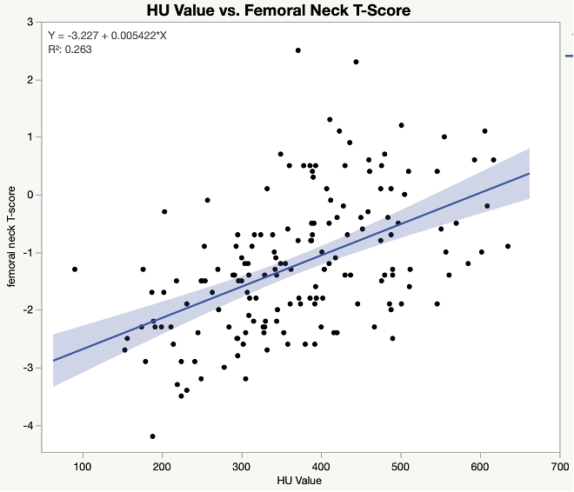

Figure 3: HU Value vs. Femoral Neck BMD
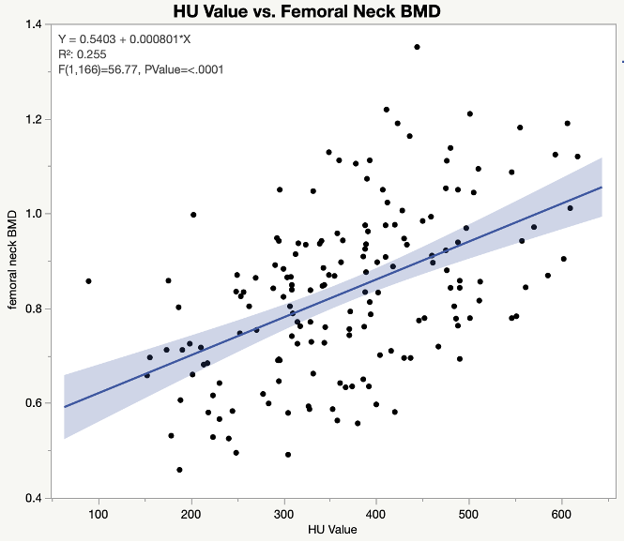
Figure 4: HU Value vs. Total Hip T-Score
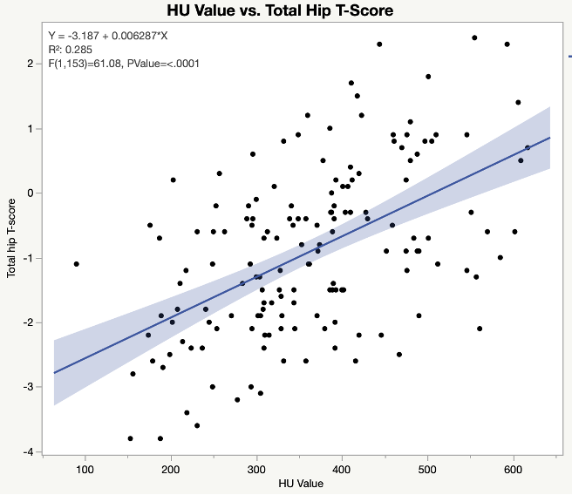
Figure 5: HU by Age in Females
Figure 6: HU by Age in Females over 50
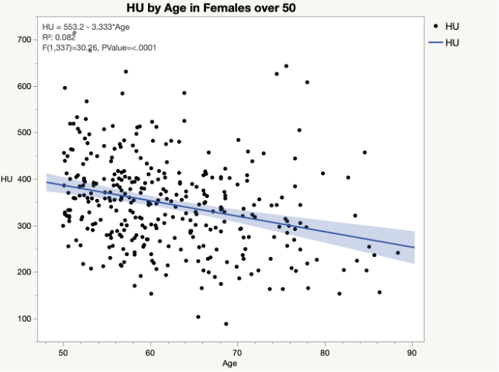
Table 1: Patient Demographics
Patients with CBCT and DXA Scans
Total Patients | 198
Females | 163 (82.3%)
Mean Age (years) | 59.4
Mean BMI | 26.04
Race
White | 166
Black | 28
Asian | 4
Ethnicity
Hispanic/Latino | 3
Not Hispanic/Latino | 194
Unknown | 1

